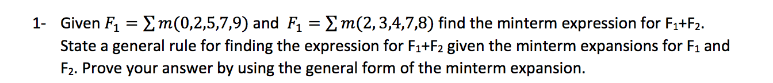

F1 + F2 = Σm(0, 2, 3, 4, 5, 7, 9)

Rule: You can add the minterm expressions because each minterm is or’ed together, and since F1 and F2 are also or’ed together, by the associative property, you can combine everything and or it all together.

F2 =

0010 a’b’cd’ +

0011 a’b’cd +

0100 a’bc’d’ +

0111 a’bcd +

1000 ab’c’d’

F1 =

0000 a’b’c’d’ +

0010 a’b’cd’ +

0100 a’bc’d’ +

0111 a’bcd +

1001 ab’c’d

Therefore, F2 = a’b’c’d’ + a’b’cd’ + a’bc’d’ + a’bc’d’ + a’bcd + ab’c’d’ + ab’c’d

Which is Σm(0, 2, 3, 4, 5, 7, 9).

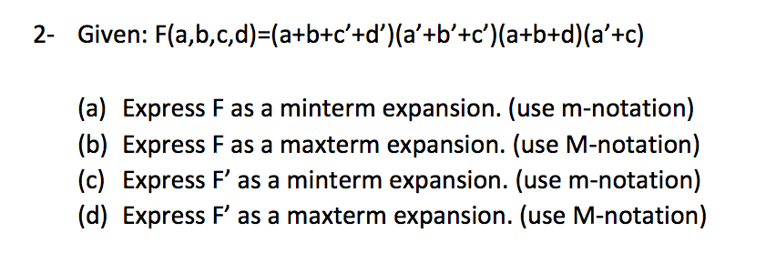

First I will put all the variables in each term by multiplying by 1.

(a+b+c’+d’)(a’+b’+c’)(d+d’)(a+b+d)(c+c’)(a’+c)(b’+b)(d’+d) Identity

{(a+b+c’+d)(a’+b’+c’+d) )(a’+b’+c’ + d’)(a+b+c+d)(a+b+c’+d) Distributive

(a’ + b’ + c + d’) (a’ + b’ + c + d) (a’+b + c+d’) (a’+b + c + d)}

Your Maxterm values:

1101, 0001, 0000, 1111, 1101, 0010, 0011, 0110, 0111

Sorted Maxterm values:

0000, 0001, 0010, 0011, 0110, 0111, 1101, 1111

a)

F = Σ m(4, 5, 8, 9, 10, 11, 12, 14)

b)

All values not minterm

F = ∏ M(0, 1, 2, 3, 6, 7, 13, 15)

c)

F’ = Σm(0, 1, 2, 3, 6, 7, 13, 15)

d)

F’ = ∏m(4, 5, 8, 9, 10, 11, 12, 14)



a’(b’ + d) + acd’ Given

a’b’ + a’d + acd’ Distributive

a’b’ (c+c’)(d+d’) + a’d(c+c’)(b+b’) + acd’(b+b’) Identity

a’b’c(d+d’) + a’b’c’(d+d’) + a’cd (b+b’) + a’c’d(b+b’) + abcd’ + ab’cd’ Distributive

a’b’cd + a’b’cd’ + a’b’c’d + a’b’c’d’ + a’bcd + a’b’cd + a’bc’d + a’b’c’d + abcd’ + ab’cd’

Thus you have the values

0011, 0010, 0001, 0000, 0111, 0011, 0101, 0001, 1110, 1010

Sorted values:

0000, 0001, 0010, 0011, 0101,0111,1010

F = Σm(0, 1, 2, 3, 5, 7, 12)

DESIGN – See Attached Paper

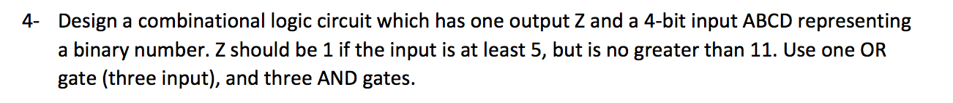

DESIGN – See Attached Paper

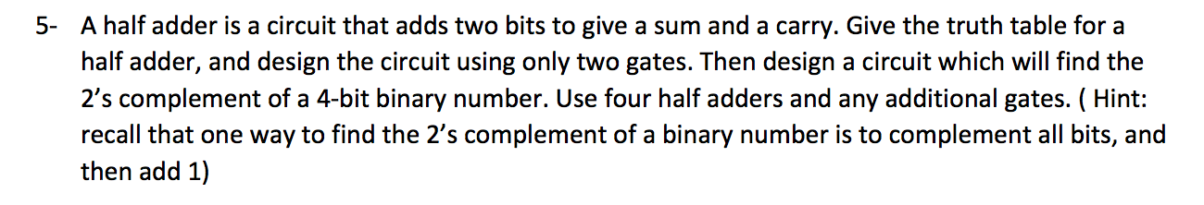

|  |  |  |  |
| --- | --- | --- | --- |
| AB | BC | Carry | Sum |
| 00 | 00 | 0 | 0 |
| 01 | 01 | 1 | 0 |
| 10 | 10 | 1 | 0 |
| 11 | 11 | 1 | 0 |

DESIGN – See Attached Paper

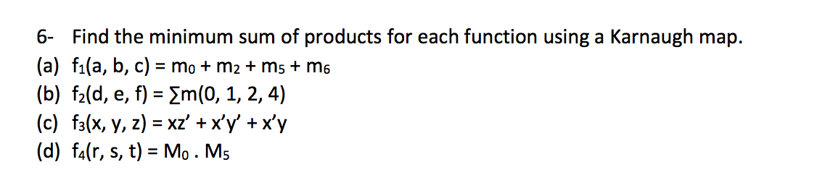

See Attached Paper for 6-12